BarBot
IoT Automated Bartender
Designed By: Cameron Miller

Documentation and Design
Version 1.0

Table of Contents
- Introduction
  - What is BarBot? – Pg. 3
  - Motivation – Pg. 3
  - Parts List and Purchase Links – Pg. 3
  - Tools Needed – Pg. 4
- Hardware
  - Wood Housing Construction – Pg. 5
  - Electrical Wiring – Pg. 10
  - Raspberry Pi GPIO Configuration – Pg. 13
- Control Software
  - Raspberry Pi Setup – Pg. 16
- Mobile App
  - Download and Installation – Pg. 17
- Cloud Resources
  - Setting up AWS resources – Pg. 18
  - Generating Access Keys for App and Pi – Pg. 18
  - Cloud Architecture – Pg. 18
- Alexa App
  - Alexa Lambda Function – Pg. 20
  - Alexa App Deployment – Pg. 20

Introduction
What is BarBot?
BarBot is an Internet of Things (IoT) automated bartender capable of mixing perfectly measured cocktails from a combination of up to 10 ingredients at once (8 non-carbonated ingredients and 2 carbonated ingredients). BarBot is fully open source and can be built from inexpensive and commonly available components. In this manual, a step by step guide is provided on how to assemble and program your very own BarBot. The purpose of this project is to provide you with the base setup for BarBot and allow you to configure the software to your preferences. Because of this, I provide the source code for the Pi software, Mobile App, Alexa App, and Cloud resources so that you can deploy them yourself and modify them to fit your needs.

Motivation
In the summer of 2019, I decided to start a project that would allow me to design an IoT device from the ground up. Upon brainstorming ideas, I decided to use my passion for mixology to create a device that could whip up drinks as skillfully as a bartender can do by hand (with some exceptions of course). As a goal for this project, I wanted to combine as many different technologies as possible to gain practical experience designing a product that requires coordination between many software and hardware components. Therefore, I decided that BarBot would consist of a hardware platform that physically makes the drinks, a smartphone app to control the device, a cloud backend for certain functionalities, and an Alexa app that would allow for voice control of BarBot.

Parts List and Purchase Links
- Raspberry Pi Zero W with headers ($14.00)
- Micro SD Card ($7.49)
- GPIO Jumper Wires ($5.79)
- 8 Channel 5V Relay Module ($8.99)
- 4 Channel 5V Relay Module ($7.99)
- 2 Channel 5V Relay Module ($6.79)
- DC Step Down to USB converter ($7.59)
- 12 V DC Power Supply ($13.99)
- 18 AWG Wire (multiple colors if you want better organization) ($8.50)
- Micro USB Cable (or any micro USB you have around the house) ($5.26)
- 8x Peristaltic Pumps (or buy a multi-pack) (8 x $9.80)
- 2x Air Pumps (I bought it as part of some kit but you can buy them separately) ($20.50 for 3 pump set)
- 2x Solenoid Valves (can also be found on eBay as Keurig replacement part) (2 x $9.89)
- Stainless Steel Funnel ($10.91)
- 39.3 ft Silicone Tubing (3mm ID/5mm OD) ($13.89)
- 16.4ft Silicone Tubing (5mm ID/7mm OD) (comes with air pump kit, otherwise buy this) ($16.99)
- 2x Aquarium Air Check Valve (link is pack of 6) ($4.99)
- Plywood Board (3/8 inch thick sheet)
- Wood Screws
- 2x Wood Brackets (Flat ¼ inch bracket)
- 2x ¼ inch steel rods (3 feet long)
- Steel pipe tape ($6.90)
- 2x one liter bottles (like a carbonated water bottle from the grocery store)
- Zip ties or Velcro straps (Optional) (for cable management)

Tools Needed
- Soldering Iron
- Solder
- Hot Glue gun
- Hot glue sticks
- Wire Strippers
- Wire Cutter
- Electrical Tape
- Assorted Screwdrivers
- Power Drill
- Wood Drill Bits
- Butterfly Drill Bits
- Screws for mounting PCBs (I used 4 x ½ sheet metal screws that I had lying around)
- Bench Vice (Optional)
- Wood Saw (Table Saw)
- Laptop with MicroSD Card Reader or External Adapter
- Wi-Fi Network

*Feel free to improvise for any of the tools you don’t have.
Hardware
Wood Housing Construction

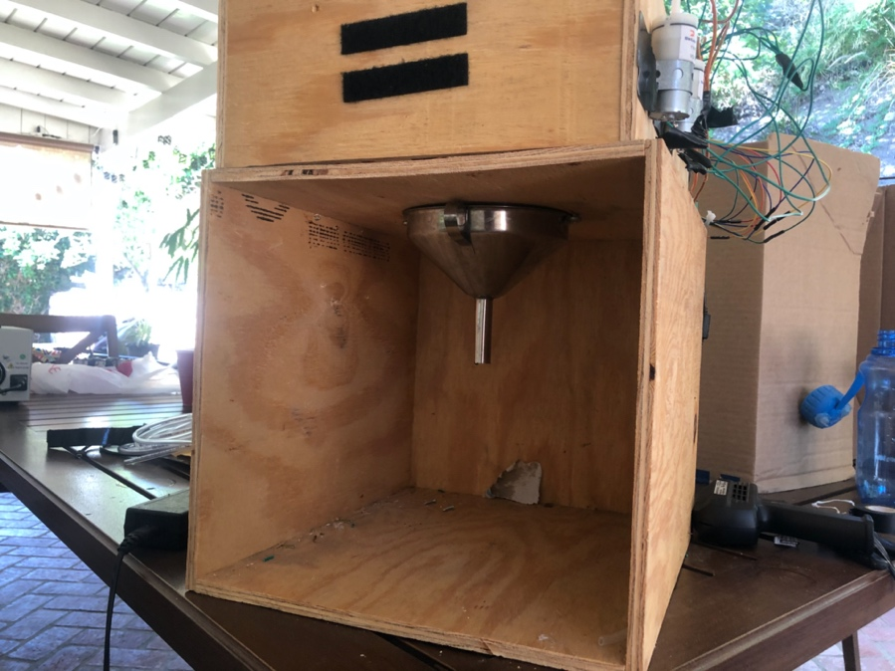
Figure 1: Lower Box Construction with the funnel shown

Lower Box Construction
- Cut 4 pieces of plywood that are 14 inches by 12 inches (side plates and top/bottom)
- Cut 1 piece of plywood that is 14 inches by 12 ¾ inches (back plate of box)
- Attach the 4 pieces together (using wood screws or a staple gun) into a square configuration that looks like a rectangular cylinder
- Attach the 1 piece onto one of the open ends of the rectangular cylinder with either screws or wood staples
- Now you should have constructed a box with one end open. This open end will be the front of the BarBot where the user places their drink cup
- Next, using a butterfly bit of size 1 ¼ inch to drill a hole in the top of this box. This is where the pumps will feed into the drink funnel

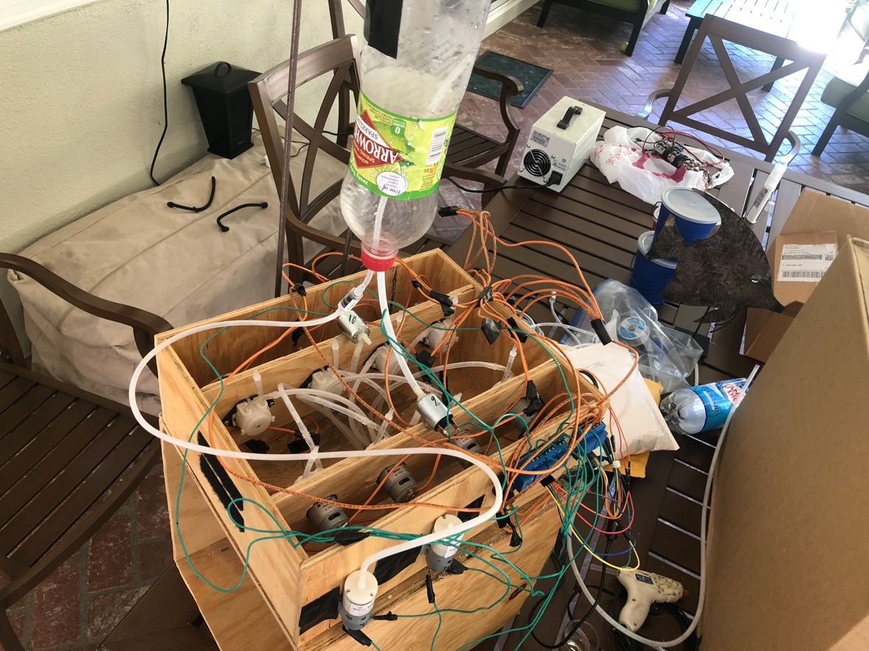
Figure 2: Top box showing pump holders and solenoids

Top Box Construction
- Cut 2 pieces of plywood that are 14 inches by 5 inches
- Cut 2 pieces of plywood that are 12 inches by 5 inches
- Place the 14x5 pieces along the sides of BarBot (running front to back)
- Place the 12x5 pieces perpendicular to the 14x5 pieces, with one at the front and the back so that you form a box the same size as the base
- Screw this box together or staple it with a staple gun
- Now take the 2 Flat Wood brackets and place them halfway from front to back on each side of BarBot
- Screw one screw into the lower box and one into the upper box on each side so that both boxes are attached

Pump Holder Construction
- Cut 2 pieces of plywood that are 13 ¼ inches by 4 inches
- These should fit snuggly simply by sliding them into the BarBot top with the 13 ¼ inch side lined up front to back with the BarBot
- Drill 4 evenly spaced holes of diameter 1 and ¼ inches in these boards using a butterfly bit
- Feel free to place the pumps in these holes at this point and mount them using screws through the provided pump brackets

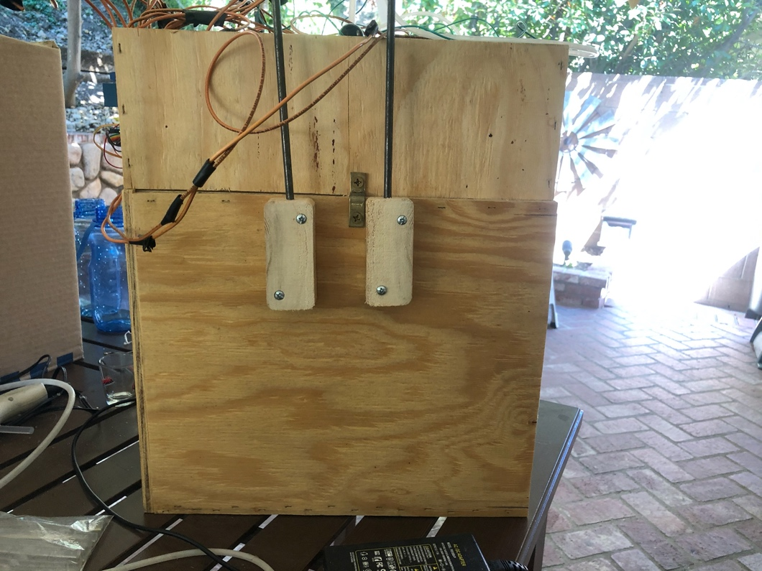
Figure 3: Beverage Holder Mounts

Carbonated Beverage Holder
- Cut two 1-inch segments from a 1.5 in x 3.5 in piece of wood
- Drill a ¼ inch hole from the top to bottom, through the center of the wood piece, as shown in Figure 3 above.
- Now connect these two pieces to one side of BarBot as shown above by drilling 2 holes in either corner of these wood mounts and screwing them to the side of BarBot with wood screws
- Now, to prepare the ¼ inch rods by bending them into a “L configuration” so that one part of the “L” is 1 foot long and the other part is 2 feet long (a bench vice is helpful for this part)
- Place the ends of the 2-foot-long sides into each of the ¼ inch holes in the mounts (they should fit somewhat tightly)

Mounting Funnel
- Center the funnel underneath the hole in the top of the BarBot lower box (refer to Figure 1)
- Mark 3 hole positions at the edge of the funnel on either side and on the back edge of the funnel
- Drill out these holes with a drill bit
- Add 3 screws with a relatively large flange to hold the funnel and don’t screw them in all the way
- The funnel should slide into and out of place by sliding the edges underneath the screws
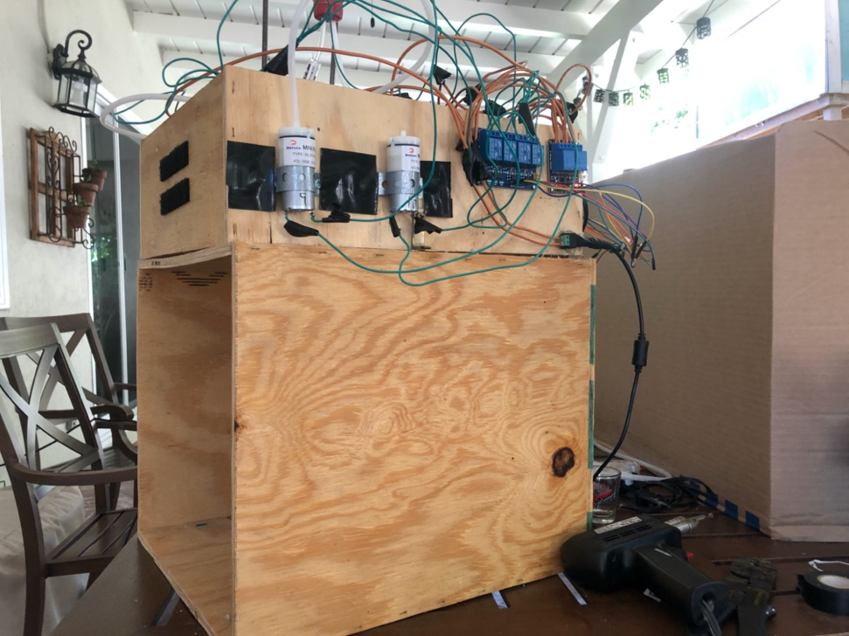
Figure 4: Air pump mounting (ends covered with tape because they were sharp)

Mounting Air Pumps
- On the opposite side of the BarBot, determine a place to mount the air pumps which don’t come with a bracket
- Cut 2 pieces of steel pipe strap, long enough to wrap around the pumps and screw in on either side (refer to Figure 4)
- Screw each side of the pipe straps to BarBot while they are wrapped around the air pumps and holding them fairly tightly

Mounting Solenoid Valves
- Since the solenoid valves also do not have brackets, they can simply be hot glued to the top of the BarBot
- In the middle of the top side on each of the peristaltic pump holders, place a glob of hot glue and hold the solenoid with one valve connection facing towards the center of BarBot and the other facing down. (See Figure 2)
- Hold the solenoids on the glue until cooled
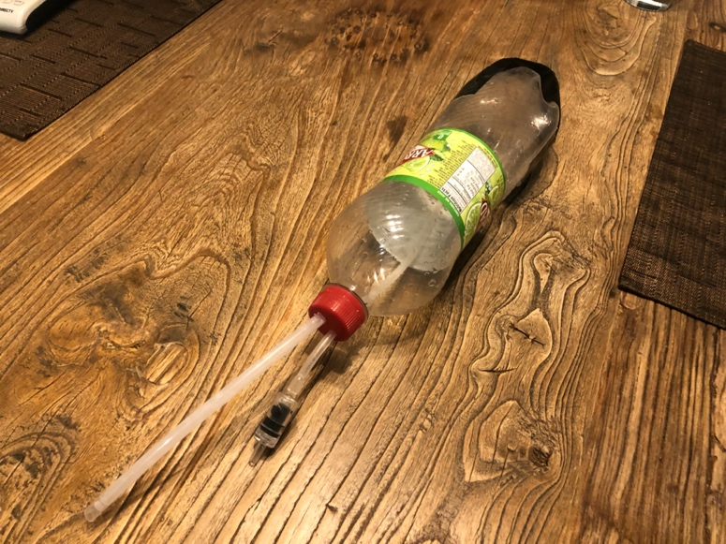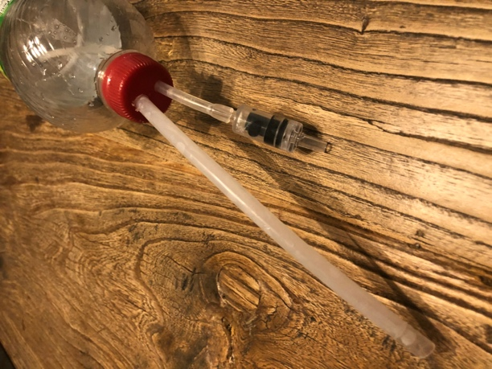
Figure 5: Carbonated Beverage Container; right side shows the tubes running through the cap

Configuring Carbonated Beverage Containers
- Drill a roughly 4 mm hole in the cap of each of your 1-liter bottles (not in the center)
- Drill a roughly 6 mm hole in the cap of each of your 1-liter bottles
- Cut a piece of 3 mm ID/5 mm OD tubing that can reach from the bottom of the bottle and out of the 4 mm hole with about 1-2 inches of excess tube hanging out
- Run the 3 mm ID/5 mm OD tube through the 4 mm hole so it reaches the bottom of the bottle (you can widen the hole if necessary, but it should be a tight fight to ensure liquid doesn’t leak out
- On the end of this tube, connect the aquarium check valve with the flow arrow pointing into the bottle
- Cut a piece of 5 mm ID/7 mm OD tubing that can reach from the bottle cap to the solenoid valve when the bottle is hanging from the steel rod above
- Insert this tube into the cap with so that only about ½ inch is inside the bottle
- Connect the other end of the tube to the solenoid valve
- Cut 2 pieces of 3 mm ID/5 mm OD tubing that can reach from the aquarium check valve to the air pumps. Connect to each of the air pumps
- Create a handle out of duct tape and attach to the bottom of each bottle (Figure 5)
- Hang bottles from each of the ¼ steel rods above the solenoid valves
* Feel free to use a more aesthetically pleasing bottle

Cutting Peristaltic Pump Tubes
- Cut 8 pieces of 3 mm ID/5 mm OD tubing that can reach from each pump to inside the funnel hole
- Cut 8 pieces of 3 mm ID/5 mm OD tubing that can reach from each pump to the bottom of an ingredient bottle placed next to the BarBot
- Connect each of these tubes to the peristaltic pumps (you may have to test which direction the pumps pump) so the tubes to the funnel are output tubes and the tubes to the bottles are input tubes
Electrical Wiring
The electrical configuration for BarBot is what allows the Raspberry Pi to programmatically control each of the pumps needed to make cocktails. The electrical part may look intimidating if you don’t have any experience, however I tried to make it as simple as possible and off explanations of every part.

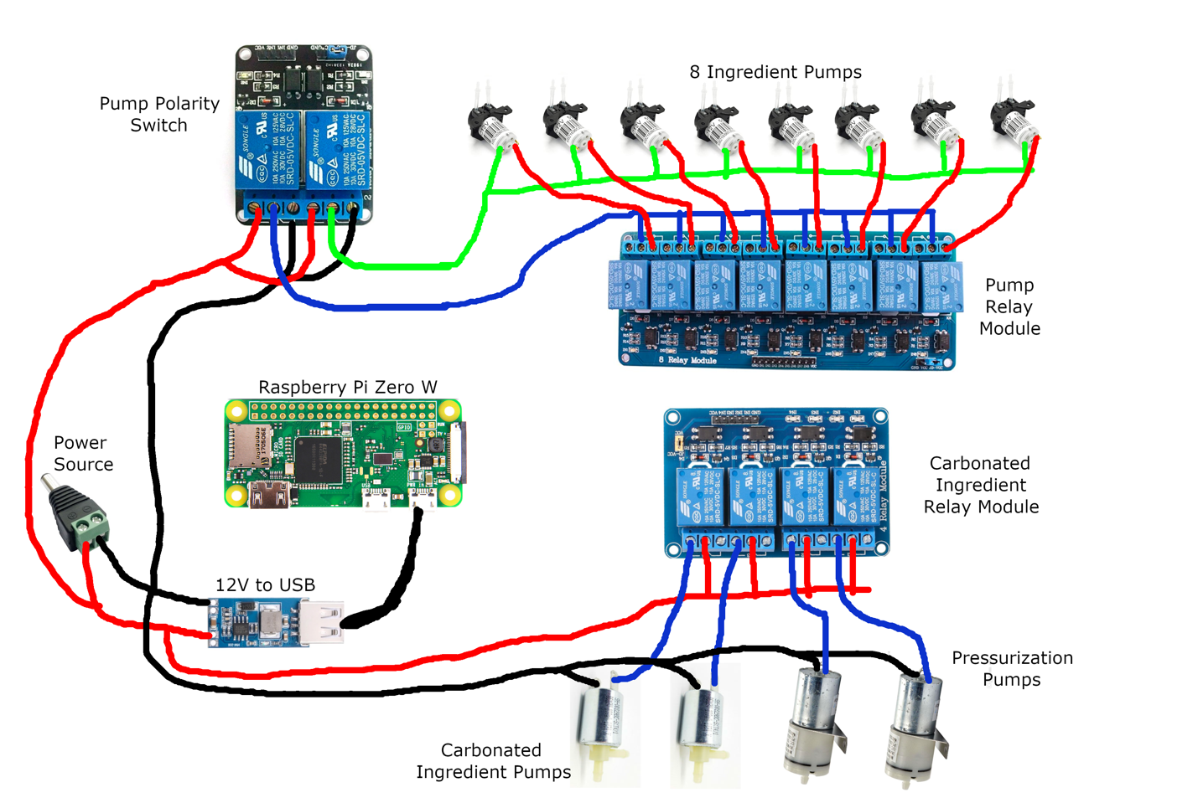
Figure 6: This is the full circuit diagram of the BarBot electrical system (excluding GPIO connections). *And yes, I did draw this in Paint if you were wondering….

- Power Supply Integration
  - To start, the circuit must get power to run everything, so the Power Supply will be integrated first. In the power supply you purchased, you will find a female connector with two screws on the back. First you should decide where on the BarBot you would like the plug to be, and once you have decided you can simply hot glue the connector onto the wood frame (or use some other method of adhesion).
  - Next, cut two pieces of the 18 AWG wire and about ½ inch on either end of the wire
  - Screw each of the wires into the terminals on the end of the connector
- 12V DC to USB Converter
  - In order to run the Raspberry Pi off of the 12 Volt power supply, we must step down the voltage to 5 Volts and provide a USB port. If your USB converter has screw hole in it, simply drill pilot holes in the BarBot frame using a proper sized drill bit.
  - Next, cut 2 pieces of wire long enough to reach from the end of the wires coming from the Power connector to the USB converter
  - Solder the end of these wires to each of the wires coming out of the Power connector (do not wrap in tape yet)
  - Solder the other end of these wires to the connectors on the USB converter (be sure the positive wire coming from the Power connector is connected to the positive terminal on the USB converter, and vice versa)
  - Next, screw the Converter onto the frame, being careful not to screw it on too tightly which could damage the PCB.
  - (Optional) If your Converter does not have screw holes, you can hot glue the bottom of the Converter to the side of the BarBot frame.
- Raspberry Pi Zero W
  - Now that we have a power supply for the Raspberry Pi, we must mount the Pi and connect it to the USB converter. First drill four pilot holes in the BarBot frame to match the four holes on the Pi
  - Gently screw the Pi onto the BarBot frame
  - Connect the Micro USB cable to the Pi’s power connector and plug the other end into the USB converter
- Pump Polarity Switch
  - In order to provide power to the peristaltic pumps and allow them to pump in either direction, we must connect the 2-relay module that can be used to reverse the polarity provided to the pumps. To do this we first need to add two new 12-volt source wires from the Power connector. Determine where you would like to mount the relay module onto the BarBot frame and measure out two wires that can reach from the Power connector to the mounting place.
  - Next, cut two wires to this length and strip about ½ inch from each end of the wire
  - Solder these wires to the positive and negative wires coming out of the Power connector (where you previously soldered the wire that go to the USB converter)
  - Next, drill pilot holes into the BarBot frame for mounting the 2-relay module
  - Screw the 2-relay module to the BarBot frame, being careful not to over-tighten screws
  - Cut 4 short wires (a couple of inches each) and strip each of the ends
  - Solder two of these short wires to the end of the longer positive and negative wires you just created so the end looks like a “Y”
  - Screw the two short wires coming from the positive wire into the “Normally Open” terminals on the relay module
  - Screw the two short wires coming from the negative wire into the “Normally Closed” terminals on the relay module
  - Next, cut two wires around 8-12 inches in length and strip about ½ inch from each end
  - Screw each of these wires into the “Common” terminals on the relay module. These will serve as the power bus connections for all of the peristaltic pumps
- Peristaltic Pump Relay Module (8 relay module) and Peristaltic Pumps
  - Pick a spot to mount the 8-relay module onto the BarBot frame. Drill 4 pilot holes
  - Screw the 8-relay module onto the frame, being careful not to overtighten the screws
  - Cut 8 pieces of wire that are long enough to reach from the wire coming out of the Pump Polarity Relay to each of the 8 peristaltic pumps. Strip about ½ inch off each end of the wires.
  - Solder 8 of these pieces to one of the wires coming out of the Pump Polarity Relay. This may be difficult with so many wires, so you could definitely use some sort of terminal connectors if you want, however, to keep it cheap I simply soldered all 8 wires together with a rather large solder.
  - Solder the other end of these wires to each of the 8 peristaltic pumps, respectively
  - Cut 8 pieces of wire that are long enough to reach from the Pump Polarity Relay to the 8-relay module
  - Solder each of these 8 wires to the remaining wire coming out of the Pump Polarity relay
  - Screw each of these 8 wires into the 8 “Common” terminals on the 8-relay module
  - Cut 8 pieces of wire that are long enough to reach from the 8-relay module to the peristaltic pumps
  - Screw each of these 8 wires into the 8 “Normally Open” terminals on the 8-relay module
  - Solder the other end of each of these 8 wires to the positive terminal on each of the peristaltic pumps, respectively
- Carbonated Ingredient Relay Module, Air Pumps, and Solenoid Valves
  - Pick a spot to mount the 4-relay module onto the BarBot frame and drill 4 pilot holes
  - Screw the 4-relay module onto the frame, being careful not to overtighten the screws
  - Cut a piece of wire that is long enough to reach from the Power Connector’s negative wire to where the Solenoid valves are located
  - Strip about ½ inch from each side of this wire
  - Solder the wire to the negative connection (where you soldered the wires going to the Reverse Polarity Relay and the USB convert) coming from the Power Connector
  - Cut 4 wires long enough to reach from the other end of the negative wire (which you just soldered) to each of the air pumps and solenoid valves. Strip the ends of these wires
  - Solder each of the 4 wires to the end of the negative wire you just created coming from the Power Connector
  - Solder the other end of these 4 wires to each of the 4 negative terminals on the 2 air pumps and 2 solenoid valves
  - Cut a wire long enough to reach from the Power Connector’s positive wire to the 4-relay module. Strip both ends of the wire
  - Solder one end of this wire to the positive wire coming from the Power Connector (where you soldered the wires going to the Reverse Polarity Relay and USB converter)
  - Cut 4 short wires that can reach from the other end of the wire you just soldered to each of the 4 relays. Strip both ends of these wires
  - Solder each of these 4 wires to the end of the wire you just created from the Power Connector
  - Screw the other end each of these 4 wires into the 4 “Common” terminals on the 4-relay module
  - Cut 4 wires that can reach from the 4-relay module to each of the 2 air pumps and 2 solenoid valves
  - Solder the wires coming from relays 1 and 2 to the 2 solenoid valves’ positive terminals, respectively
  - Solder the wires coming from relays 3 and 4 to the 2 air pumps’ positive terminals, respectively
- Cleanup
  - Wrap all solder connections with electrical tape to keep them insulated
  - Use zip ties or Velcro straps for wire management and organization

This completes the wiring of the main electrical backbone of the BarBot. At this time, it would be a good idea to compare your wiring to Figure 6 above to make sure everything is accurate.

Raspberry Pi GPIO Configuration
Now that all of the electrical components are wired together, BarBot needs to be able to control these pumps programmatically. This is where General Purpose Input/Output (GPIO) pins on the BarBot come into play. The following table will describe which GPIO pins on the Raspberry Pi connect to which components and which pins on those components.

Table 1: Raspberry Pi GPIO connections
Raspberry Pi GPIO | Component Name | Pin Number/Name
5V pin | 8-relay module | VCC
GND | 8-relay module | GND
GPIO 26 | 8-relay module | IN1
GPIO 19 | 8-relay module | IN2
GPIO 13 | 8-relay module | IN3
GPIO 6 | 8-relay module | IN4
GPIO 5 | 8-relay module | IN5
GPIO 21 | 8-relay module | IN6
GPIO 20 | 8-relay module | IN7
GPIO 16 | 8-relay module | IN8
5V *see note below | 4-relay module | VCC
GPIO 11 | 4-relay module | IN1
GPIO 9 | 4-relay module | IN2
GPIO 2 | 4-relay module | IN3
GPIO 3 | 4-relay module | IN4
GND | 4-relay module | GND
5V *see note below | Polarity Switch Relay | VCC
GPIO 17 | Polarity Switch Relay | IN1
GPIO 27 | Polarity Switch Relay | IN2
GND | Polarity Switch Relay | GND

* There are only 2x 5V pins on the Raspberry Pi, however, we will need 3 connections. Unfortunately, this means that we need to split one 5V connection. Follow the instructions below to split the 5V Pin

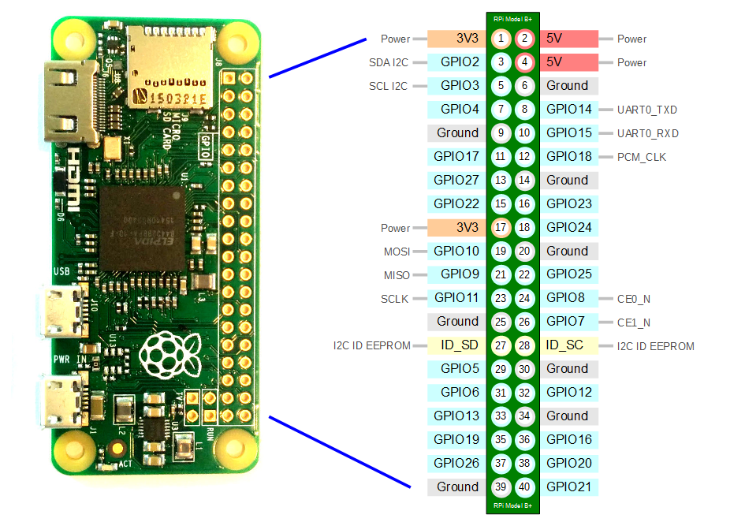
Figure 7: Raspberry Pi GPIO Pin Layout

Splitting 5V Pin
- Take a Male to Female Jumper wire and placing the Female end on the 5V pin
- Take 2 Male to Female Jumper wires and solder both Male ends to the Male end of the Jumper coming from the 5V pin
- Wrap the solder in electrical tape to insulate it

If Jumper is not long enough to reach component:
- Use Male to Female Jumper from the Raspberry Pi pin instead of Female to Female jumper
- Chain multiple jumpers together to reach the component and make the final jumper a Female to Female jumper

Control Software
NOTE: You will be asked for your AWS credentials in this section, so be sure you complete the “Setting up AWS Resources” section of this guide before completing this section

Raspberry Pi Setup (manual setup)
- Download the BarBot operating system image HERE
- Download SD Card formatter
- Download Balena Etcher
- Connect your MicroSD Card to your computer
- Format your card as FAT32 using the SD Card Formatter
- Download “Raspberry Pi OS (32-bit) Lite” image
- Flash this image onto your SD card using Balena Etcher
- Open up your file manager (File Explorer on Windows or Finder on Mac)
- Select the disk labeled “boot”
- Create a file named “wpa_supplicant.conf” and add your Wi-Fi connection information
  - Formatting and instructions can be found here
- Eject SD Card from computer and insert into the Raspberry Pi
- Power on the BarBot system
- After a minute or so, open a terminal window on your computer and type “ssh pi@rapsberrypi.local”
  - The password is “raspberry” when prompted
- Next run the command “sudo apt install git”
- Then run “git clone https://github.com/camm73/BarBot.git” to download BarBot code
- Run “cd BarBot” to enter folder
- Next run “./setup.sh” to begin setup script
- Follow the instructions and enter AWS credentials when prompted
- After reboot, BarBot is fully set up.
  - NOTE: the hostname is now “barbot”, so if you need to access the Pi via ssh again, use “ssh pi@barbot.local”

* NOTE: Planning to add a pre-configured BarBot Image in the future to simplify configuration

Mobile App

Download and Installation (iPhone only & you must have a Mac)
This process will allow you to download and build the source code for the BarBotApp. Since the goal of this project is to give you a base for the project, I decided to provide the source code and not publish the app to the app store so that you can modify the app as you see fit.

- Open terminal and navigate to a folder where you want to download the BarBotApp source code
- Clone the repository by running “git clone https://github.com/camm73/BarBotApp.git”
- Open “BarBotApp” folder and then go to “src/config”
- Create a file called “awsCreds.json”
- Complete the “Setting Up Cloud Resources” section of this guide if you haven’t already before continuing
- Paste the following inside this file (referring to “BarBotAppUser” AWS user credentials):
{
"accessKeyId": "<your AWS access key ID",
"secretAccessKey": "<your AWS secret access key>",
"region": "<name of your AWS region>",
"imageBucket": "<name of your S3 Bucket with cocktail images>"
}
- Follow this guide on creating and configuring a free Apple Developer account if you don’t already have one
- Inside the BarBotApp folder you downloaded, open the “ios” folder
- In the “ios” folder open, “BarBot.xcworkspace”
- Use the same guide above to configure your developer signing for the app
- To install the app as a release version, go to Product -> Edit Scheme
- Change the scheme to “Release” and save the change
- Select your iPhone as the destination device
- Begin building and installing the app on your iPhone

IMPORTANT If you plan to post your modifications to the BarBot app publicly, be sure to add the “awsCreds.json” file to your “.gitignore” file so that you don’t give other people access to your AWS account.

*More detailed instructions can be found on the React Native website
**NOTE: The certificate for the installing the app on your phone only lasts 7 days. You will have to re-install the app every 7 days or get a paid Apple Developer Account to keep the app running on your phone. This is an Apple limitation and unfortunately, I can’t do anything about it
*** Technically since this is a React Native app, it is cross-platform and can run on Android, however, I have not tested this and have almost definitely not configured everything correctly for Android.

Cloud Resources

Setting up AWS Resources
- Create an AWS developer account
- Sign into AWS and Navigate to CloudFormation
- Download the BarBot CloudFormation template
- Change the “Bucket Name” field in the template to be a unique name
  - NOTE: If you don’t pick a unique name, then the S3 bucket deployment will fail
- Create a new Stack in CloudFormation with the template
- Your AWS resources have now been provisioned to work with BarBot

Generating Access Keys for App and Pi
In order for the BarBot app and the BarBot Raspberry Pi to be able to use the necessary AWS resources, you must generate access keys.

BarBotPi User Keys:
- Navigate to IAM in AWS
- Go to the “Users” tab in the IAM menu
- Select the user named “BarBotPi”
- Navigate to the “Security credentials” tab
- Select “Create access key” and follow the steps
- Download the generated keys (you won’t be able to access them again without downloading)
- Enter these keys when running the “aws configure” command on the Pi or when prompted in the BarBot setup script on the Pi (detailed in the Raspberry Pi Configuration section)

BarBotApp User Keys:
- Complete steps 1-2 above
- Select the user named “BarBotApp”
- Complete steps 4-6 above
- Add the keys to the “awsCreds.json” file in the BarBot app “config” folder (as described in the Mobile App Setup section)

Cloud Architecture
- “BarBot-Recipe” DynamoDB Table
  - This table is used to hold all recipes that BarBot can make. When you create a new recipe in the BarBotApp, this is the table that is updated
  - The primary key for this table is a string named “cocktailName”
  - Other fields
    - Amounts field
      - The “amounts” field is a Map that relates string names of ingredient to a Number representing how many shots of the ingredient (1.5 fl Oz per shot)
    - Ingredients field
      - The “ingredients” field is a List of string names for a cocktail’s ingredients
- “BarBot-cocktailStats” DynamoDB Table
  - This table is not particularly important, but it simply keeps track of how many times a given cocktail has been ordered
  - The primary key for this table is a string named “cocktailName”
  - Other fields
    - Count field
      - The “count” field is simply a Number that is the number of times the given cocktail has been ordered
- “<your chosen bucket name>” S3 Bucket
  - This S3 bucket is used to store the cocktail images that you upload from the app
- “BarBotPi” IAM User
  - This IAM user is for the BarBot’s Raspberry Pi and provides AWS access to select resources
  - This IAM user has an inline Policy Document that allows access to “BarBot-Recipe” and “BarBot-cocktailStats” DynamoDB tables
- “BarBotApp” IAM User
  - This IAM user is for the BarBot App and provides AWS access to the “BarBot-Recipe” DynamoDB table and your cocktail images S3 bucket
  - Uses an inline Policy Document to list resource access and privileges
- (Optional) BarBot IoT Core Device
  - Optionally, if you wish to use the BarBot Alexa app, you must create an IoT “Thing” named “BarBot”
  - In addition, you must add the certificates generated for this IoT thing to the “certs” folder inside of “BarBot/controller” on the Pi
  - When using the Alexa app, Pi will be reading from your IoT Thing’s shadow which is update from the Pi. It will also control the Pi, by sending commands on the IoT topic “barbot-main”

Alexa App
Since the Alexa App is optional, I won’t go into too much detail about it. The app simply allows you to control BarBot with your voice. For this to work, you must configure the BarBot IoT Thing in AWS as described in the previous section.

Alexa Lambda Function
- Download the source code for the BarBot Alexa App Lambda Function
- Create a Lambda function in AWS with this source code
  - Make sure the Lambda function has an IAM Policy that allows access to the IoT topic “barbot-main” and to all the “BarBot” Thing’s functionality

Alexa App Deployment
- In the Alexa Developer Console, create an Alexa Skill for BarBot
- Create a Wake Word of your choosing
- Create a “MakeCocktail” Intent with one slot named “cocktail” with slot type “AMAZON.Drink”
  - Add sample utterances for your MakeCocktail command
- Create a “MenuIntent” Intent with no slots
  - Add samples utterances for invoking the MenuIntent
- Create a “SetAlcoholModeIntent” Intent with one slot named “setting” with a custom slot type named “ON_OFF” which allows simple toggling
- Link the Lambda function as the Backend for the Skill
- Train and Deploy the skill to your Alexa in development mode

NOTE: More detailed instructions for creating and managing Alexa Skills can be found on Amazon’s website

